U1

#uppgift 1

x1<-1/3;

x2<-1/4;

if (abs(x1-x2-1/12)<.Machine$double.eps){

print("Teacher said true")

} else{

print("Teacher lied")}

U2

> myd<-function(f,x,e) (f(x+e)-f(x))/e

> myd(function(x) x, 100000,10^-15)

[1] 0

U3

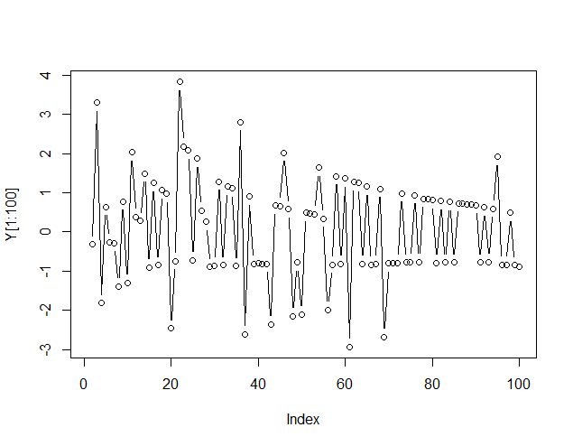

U4

> solve(A,b)

Error in solve.default(A, b) :

system is computationally singular: reciprocal condition number = 3.29689e-17

> #Error in solve.default(A, b) :

> # system is computationally singular: reciprocal condition number = 3.29689e-17

> kappa(A)

[1] 4.160888e+15

After scaling

> kappa(A)

[1] 6.64325e+11